**1. Python program to check leap year**

**PROGRAM:**

year = int(input("Enter a year: "))

if (year % 4 == 0 and year % 100 != 0) or (year % 400 == 0):

print(f"{year} is a leap year.")

else:

print(f"{year} is not a leap year.")

**OutPut:**

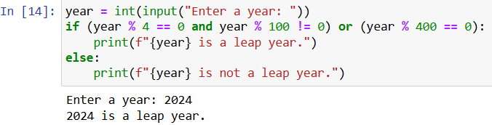

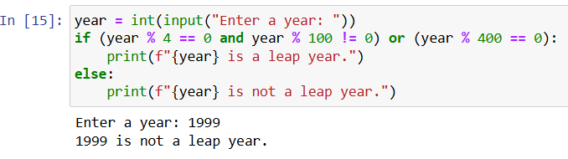

**2. Python Program to Find the Largest Among Three Numbers**

**PROGRAM:**

a = float(input("Enter the first number: "))

b = float(input("Enter the second number: "))

c = float(input("Enter the third number: "))

largest = max(a, b, c)

print(f"The largest number is {largest}")

**OutPut:**

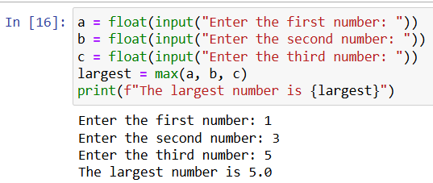

**3. Python Program to Check if a Number is Positive, Negative or 0**

**PROGRAM:**

num = float(input("Enter a number: "))

if num > 0:

print("Positive number")

elif num < 0:

print("Negative number")

else:

print("Zero")

**OutPut:**

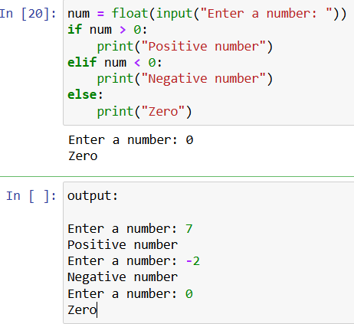

**4. A toy vendor supplies three types of toys: Battery Based Toys, Key-based Toys, and Electrical Charging Based Toys. The vendor gives a discount of 10% on orders for battery-based toys if the order is for more than Rs. 1000. On orders of more than Rs. 100 for key-based toys, a discount of 5% is given, and a discount of 10% is given on orders for electrical charging based toys of value more than Rs. 500. Assume that the numeric codes 1,2 and 3 are used for battery based toys, key-based toys, and electrical charging based toys respectively. Write a program that reads the product code and the order amount and prints out the net amount that the customer is required to pay after the discount.**

**PROGRAM:**

product_code = int(input("Enter the product code (1-Battery, 2-Key, 3-Electrical): "))

order_amount = float(input("Enter the order amount: "))

if product_code == 1 and order_amount > 1000:

discount = order_amount * 0.10

elif product_code == 2 and order_amount > 100:

discount = order_amount * 0.05

elif product_code == 3 and order_amount > 500:

discount = order_amount * 0.10

else:

discount = 0

net_amount = order_amount - discount

print(f"Net amount to be paid: Rs. {net_amount:.2f}")

**OutPut:**

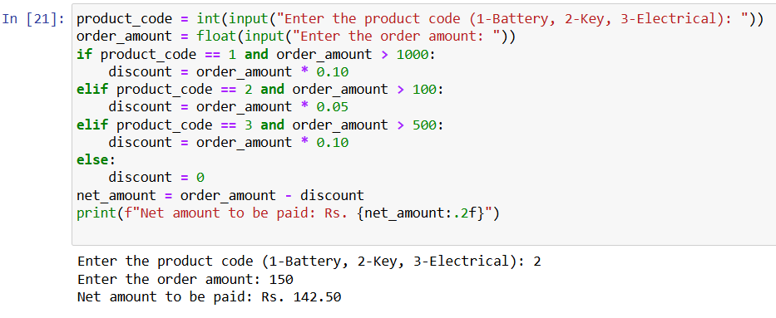

**5. A transport company charges the fare according to following table:**

**Distance Charges**

**1-50 8 Rs./Km**

**51-100 10 Rs./Km**

**> 100         12 Rs/Km**

**PROGRAM:**

distance = float(input("Enter the distance in kilometers: "))

if 1 <= distance <= 50:

fare = distance * 8

elif 51 <= distance <= 100:

fare = (50 * 8) + (distance - 50) * 10

else:

fare = (50 * 8) + (50 * 10) + (distance - 100) * 12

print(f"Total fare for {distance} kilometers is Rs. {fare}")

**OutPut:**

